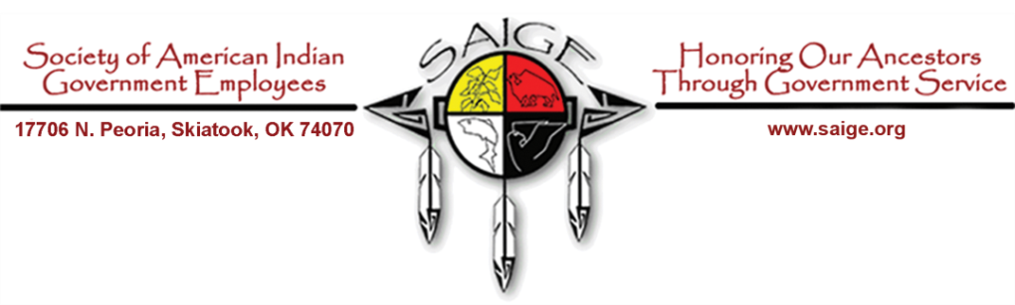
SOCIETY OF AMERICAN INDIAN GOVERNMENT EMPLOYEES (SAIGE)
2021 MILITARY MERITORIOUS SERVICE AWARD

2021 AWARD NOMINATION TRANSMITTAL FORM
NAME OF THE AWARD: 2020 Society of American Indian Government Employees Military Meritorious Service Award
Nominee Information

Name of Nominee:

Position Title and Grade:

DoD Component/ Department/ Agency/ Organization:

Tribal Membership or Ancestry:

Veteran Service Statement and Condition of Discharge:

Mailing Address:

Work Phone:
Fax Number:
Email Address:

Nominating Official’s Information
Name of Nominating Official:

Position Title/Grade:

Department/Agency/Unit:

Mailing Address:

Work Phone:

Work Fax:

Work E-mail Address:

